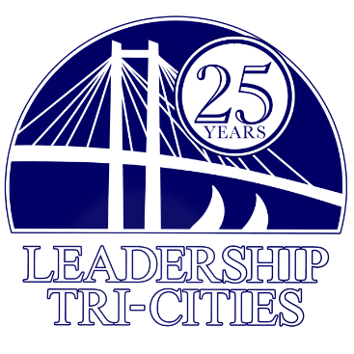
Leadership Tri-Cities Community Project Request for Proposal (RFP)

Thank you for your interest in the LTC Class XXVII Community Project. We are pleased to provide the following project guidelines and look forward to potentially working with you on your project.
INTRODUCTION AND PURPOSE:
Each Leadership Tri-Cities class is presented with the challenge of completing a “Class Project.”
The LTC Class XXVII is seeking opportunities to serve our community via the application, review and selection process described below.
- REVIEW AND SELECTION PROCESS:
All applications will go through a multi-phase approval process, including:
  - Proposals will be screened by the Leadership Tri-Cities Project Team
    - All applicants will be notified by November 3, 2023 of the recommended project that is selected to bring to LTC Board of Directors for final approval
    - The selected project will be voted on during the November 9 ,2023 LTC Special Board Meeting

- PROPOSAL CONTENT REQUIREMENTS:
Please note all applications submitted must have a project proposal that is shovel ready and a great need for the organization.
Provide a detailed written narrative of your proposed project that follows the outline below. Narrative should not exceed one page. Your proposal should include a Budget Worksheet. This does not count towards the one page limit to your proposal.
  - Answer the following questions:
    - How will this project serve our community?
    - How many families or individuals will be positively impacted by this project?
    - How does this project support or provide service across lines of social diversity?
    - Is there funding available for the project or will funding need to be raised?
    - If funding needs to be raised, estimate how much needs to be raised.
    - How long as this project been needed for your organization?

- PROJECT REQUIREMENTS AND GUIDELINES
Please take note of the following project requirements to ensure the potential project is one that meets these guidelines:
  - Selection: The project must address a local community need in partnership with a community agency
    - A community agency is loosely defined as a 501c3, school district, municipality, county, or civic group with the primary or secondary goal of improving our community
    - Must be feasible for completion within 120 days
    - The project must not promote any religious or political overtones
  - Project Execution:
    - There must be an activity during the project execution that allows engagement of LTC class members to serve in the project.
    - Must be completed within 120 days from date of approval by the LTC Board of Directors
    - Any required permits, licenses, or insurance must be clearly identified
    - Local, state, and federal guidelines will be adhered to throughout the project. Additional precautions appropriate to the project location should be communicated to the Project Team.

- PROPOSAL SUBMISSION
Proposals must be submitted by 5:00 p.m. PST on October 16, 2023 via email to Chris Mortensen at topher.mortensen@gmail.com
Questions? Contact Chris Mortensen, Class Project Manager, at topher.mortensen@gmail.com

